Using the Consumption Writer plug-in
This plug-in to EwE version 6.5 and newer writes Ecosim consumption data to CSV file when Ecosim runs, and when explicitly activated.

Configuration
To activate, navigate either to the EwE file management settings (Menu > Tools > Options > File Management, Figure 1) or to the configuration interface of the plug-in itself (Menu > Tools, Figure 2), and turn on the auto-save option.
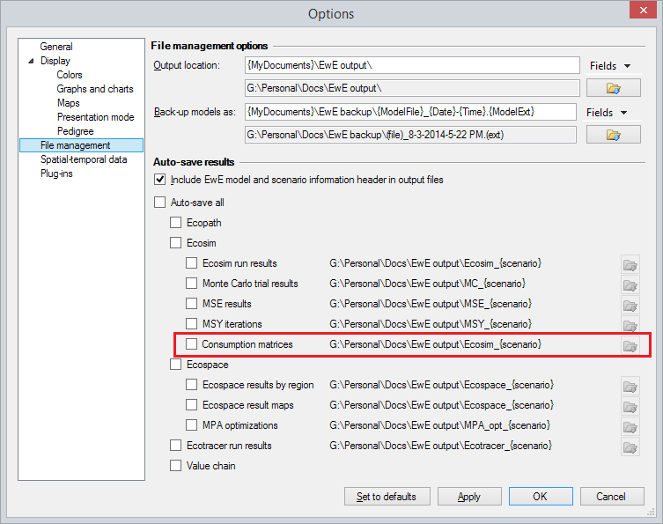
Figure 1 - Activating automatic saving of Ecosim consumption matrices
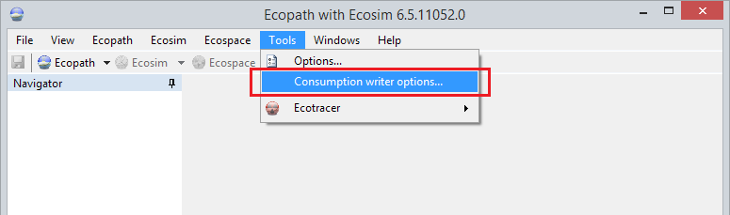
Figure 2 - Activating the consumption writer plug-in settings
The consumption writer plug-in offers a few options to customize what is written to disk (Figure 3): (i) enabling or disabling generation of Ecosim consumption matrix csv files; (ii) including detritus groups in the square consumption matrices; and (iii) including diet imports and total consumption sums (per group).

Figure 3 - Options for the consumption writer

Running
Once Ecosim runs with the plug-in activated, consumption CSV files will be saved to the path indicated in the auto-save settings (see Figure 1) for every time step, and for annual average values. The EwE Status panel will inform the user that data has been saved, and where (Figure 4).
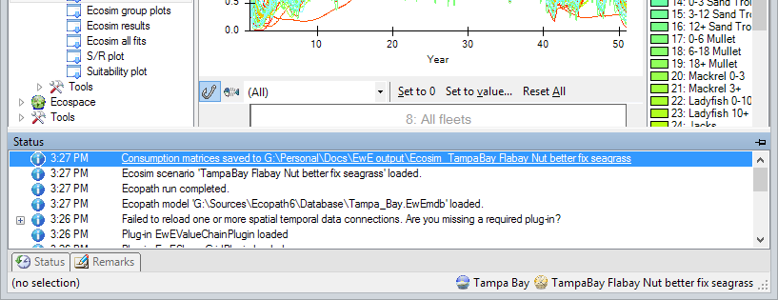
Figure 4 - The status panel provides information where data has been saved
CSV files will be named “Consumption_xxxx.csv” and “Consumption_annual_xxxx.csv”, where xxxx denotes the time step data was saved for. CSV files are formatted just like any other CSV file produced by Ecosim. Group names are listed as columns, and are implied in the same order for data rows.

Details to be aware of
The plug-in adheres to EwE-wide export settings:
- Numbers will be formatted according to US English notations, with decimal points and without thousands separators;
- CSV files will be comma separated;
- CSV files will include the EwE model and scenario header unless this functionality is explicitly turned off in the auto-save settings (see Figure 1)

